Inspection Date | 22-3-2023 | Report Walkthrough. | MACINS032 22/3/2023
Site Name | Main Campus | Location | Building K
Inspected By | Hend Alzaabi | Witnessed by

Inspection Type | General Housekeeping & Sanitation Fire Electrical Ladders Lab Food Structure Motor Vehicles Landscaping PPE Stores Emergency Evacuation

S/N | Description |  | Risk Evaluation
 |  |  | Low | Med | High
 | Trip hazard observed
 | Empty fire extinguisher found
 | Poor housekeeping
 | MCP found hindered
 | Fire extinguisher not available
 | Fire alarm panel found hindered
 | Old KU logo found in the evacuation map
 | Single insulation cable expose observe
 | Kitchen door found unlocked
Attachment |  | √ Photos Video Footage Other

S/N
 | Action | By Whom |  | By When
 | Cable management need to be done. | FM | 31-4-23
 | Empty fire extinguisher need to be removed | FM | 31-4-23
 | Housekeeping need to be done | FM | 31-4-23
 | MCP access need to be cleared | FM | 31-4-23
 | Fire extinguisher to be available | FM | 31-4-23
 | Fire alarm panel need to be accessible | FM | 31-4-23
 | Evacuation map need to be updated | FM/EHS | 31-4-23
 | Single insulation cable need to be inside the cabinet | FM | 31-4-23
 | Kitchen door need to be locked | FM | ASAP

Attached Photos
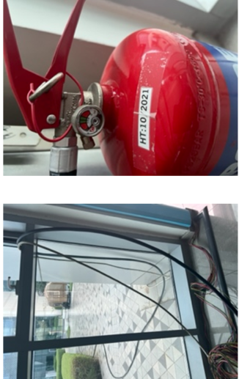 | 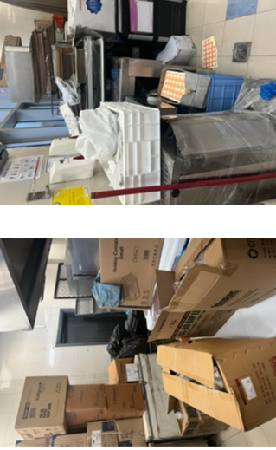 | 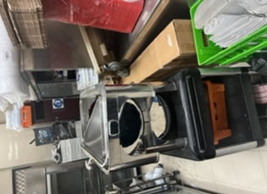
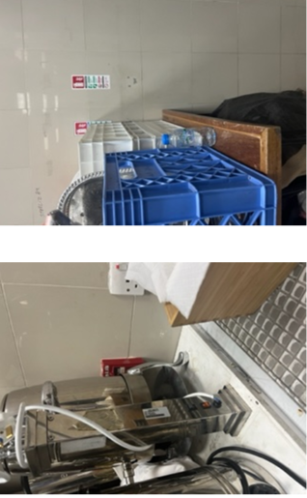 | 